New SEE model Question paper
RV COLLEGE OF ENGINEERING®
(AUTONOMOUS INSTITUTE AFFILIATED TO VTU, BELAGAVI)
I/II Semester B.E. Degree Examination, Sept 2025
COMPUTER AIDED ENGINEERING GRAPHICS ME122GL
(COMMON TO ALL BRANCHES)
Time: 03 Hours | Maximum Marks: 50

Instruction to candidates: 1. Answer both the questions using CAD software
2. Answer one question each from part A and Part B
Part A
1a. | A cone of base diameter 40mm and height 50mm rests centrally over a frustrum of a pentagonal pyramid of base side 45mm, top side 35mm and height 55mm. Draw isometric projections of the combination of solids. | 20
OR
1b | A pentagonal prism of 30mm base edges and 65mm axis length rests on HP with two of its lateral surfaces are equally inclined to VP and nearer to it. A section plane perpendicular to VP and inclined at 45° to HP bisects the axis of the prism. Draw the development of lateral surface of retained portion of the solid. | 20
Part B
2a | Create a 3D model and generate the following views. a) Front View b) Top View c) Right Side View for the object shown below.  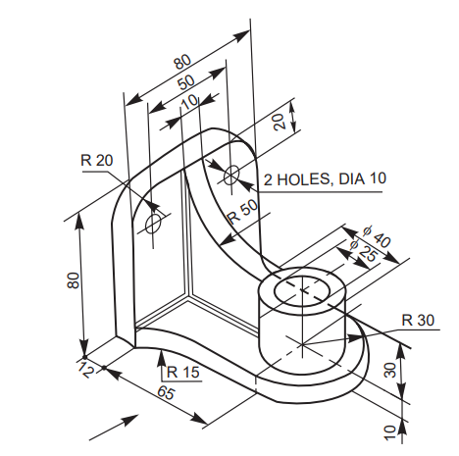 | 30
OR
2b | Create a 3D model and generate the following views. a) Front View b) Top View c) Right Side View for the object shown below.  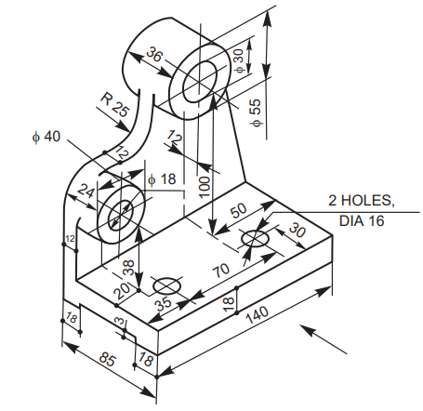 | 30

